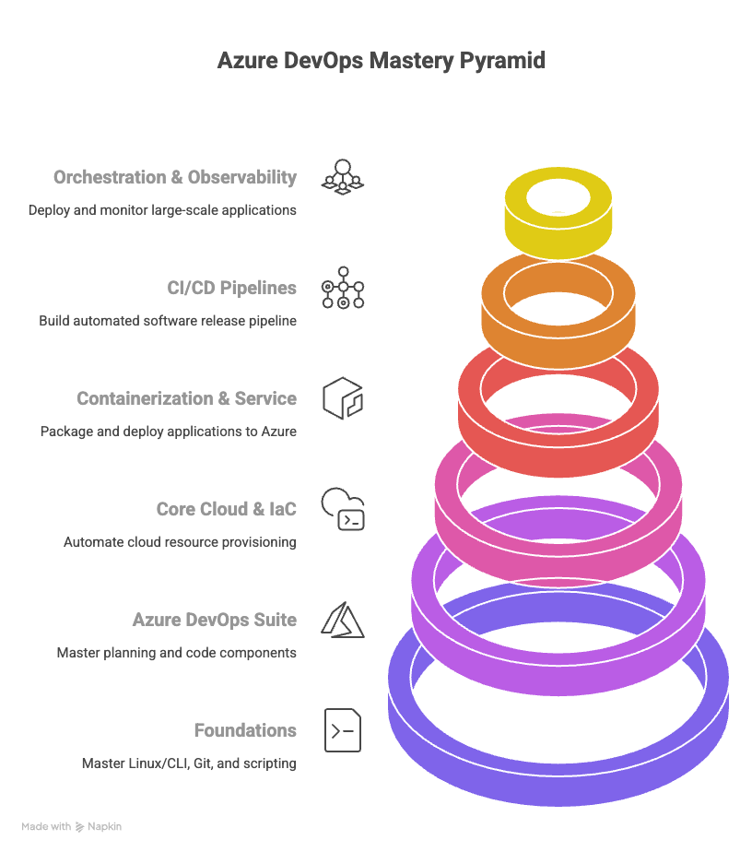
The 6-month roadmap for Azure DevOps relies heavily on mastering the integrated tools within the Azure DevOps Services suite and pairing them with essential open-source tools.

🚀 6-Month Azure DevOps Roadmap (Beginner to Job-Ready)
Month | Focus Area | Goal | Key Tools & Azure Services to Master
1 | Foundations | Master Linux/CLI, Git, and Python/PowerShell scripting. | Linux (Bash/Shell) or Windows (PowerShell), Git & GitHub, Python
2 | Azure DevOps Suite | Master the planning and code components of the integrated platform. | Azure Boards, Azure Repos, Git (Core commands)
3 | Azure Core Cloud & IaC | Understand core cloud resources and automate their provisioning using code. | Azure CLI, Azure Portal, Azure Virtual Machines (VM), Azure VNet, Terraform (or Bicep)
4 | Containerization & Service | Package applications and deploy them to the main Azure container service. | Docker (Containerization), Azure Container Registry (ACR), Azure Container Instances (ACI)
5 | CI/CD Pipelines (YAML) | Build a complete, automated software release pipeline using Azure Pipelines. | Azure Pipelines (YAML), Azure Artifacts, Azure Key Vault
6 | Orchestration & Observability | Deploy a large-scale application using Kubernetes and implement deep monitoring. Build final portfolio projects. | Azure Kubernetes Service (AKS), Azure Monitor, Prometheus/Grafana

🛠️ Essential Tools and Brief Descriptions
The Azure path emphasizes seamless integration using Microsoft's native services, supplemented by cloud-agnostic tools like Terraform.

I. Foundational & Scripting Tools (Month 1)
Tool | Category | Brief Description
Linux/PowerShell | OS/Scripting | Either Linux (Bash) or Windows (PowerShell) proficiency is essential. PowerShell is often required in enterprises running Windows Server on Azure.
Git & Azure Repos | Version Control | Git is the standard. Azure Repos provides unlimited, cloud-hosted private Git repositories, fully integrated with Azure DevOps.
Python | Scripting Language | Used for automation, managing serverless tasks (Azure Functions), and interacting with the Azure REST API via the Python SDK.
Azure CLI | Cloud Management | The command-line interface for managing all Azure resources (VMs, VNets, Storage) from the terminal. Must be mastered for scripting.

II. The Azure DevOps Suite (Month 2 & 5)
Tool | Category | Brief Description
Azure Boards | Agile Planning | Project management tool for planning, tracking, and reporting work using Agile methodologies (Scrum, Kanban).
Azure Pipelines | CI/CD Automation | The core automation engine. Used to automatically Build, Test, and Deploy code using YAML-based definitions. Supports deployment to any platform (Azure, AWS, On-Prem).
Azure Artifacts | Package Management | A repository service for hosting and sharing package feeds (e.g., NuGet, npm, Maven) used by various teams, simplifying dependency management.
Azure Test Plans | Testing | Tools for integrated manual, exploratory, and automated testing, allowing for comprehensive quality assurance within the DevOps cycle.

III. Infrastructure as Code (IaC) (Month 3)
Tool | Category | Brief Description
Terraform | IaC (Cloud-Agnostic) | The industry standard for defining and provisioning cloud infrastructure using HCL. Highly preferred in large, multi-cloud enterprises in India.
Bicep / ARM | IaC (Azure Native) | Bicep is the new, cleaner, declarative language from Microsoft (built on top of the original ARM JSON templates) to provision Azure resources. Essential for jobs that demand native Azure IaC.
Ansible | Configuration Management | An agentless tool used to automate software installation and configuration inside Azure VMs, ensuring environment consistency.

IV. Azure Compute & Orchestration (Month 4 & 6)
Tool | Category | Brief Description
Docker | Containerization | Packages applications and dependencies into standardized containers. Used locally and to create images for Azure deployment.
Azure Container Registry (ACR) | Image Registry | A private, secure, and scalable Docker image registry within Azure used to store and manage your container images.
Azure Kubernetes Service (AKS) | Container Orchestration | Azure's fully managed Kubernetes service. Simplifies the deployment, scaling, and management of large, containerized microservice applications.
Azure Functions | Serverless Compute | An event-driven, serverless computing platform. Used to run small, reactive code snippets (often Python or C#) for automation without managing VMs.

V. Monitoring & Security (Month 5 & 6)
Tool | Category | Brief Description
Azure Monitor | Observability | Azure's native tool for collecting metrics, logs, and events from all cloud resources. Used to set up alerts and gain insights into application health.
Azure Key Vault | Secret Management | A secure service for storing and tightly controlling access to sensitive data, such as API keys, passwords, and cryptographic certificates, used in pipelines.

🎯 6-Month Certification Strategy
- Primary Goal: AZ-900: Microsoft Azure Fundamentals (Optional, but good for building confidence).
- Most Important Goal: AZ-104: Microsoft Azure Administrator
  - Why? This is the most crucial associate-level certification. It proves you can provision, manage, and monitor Azure resources (VMs, networking, storage), which are the building blocks for any DevOps pipeline.
- Stretch Goal (Highly Recommended): AZ-400: Microsoft Certified: Azure DevOps Engineer Expert
  - Why? While typically for experienced professionals, preparing for the AZ-400 shows a commitment to the entire Azure DevOps methodology (Boards, Repos, Pipelines, IaC, Security), which is a massive advantage in the job market.

